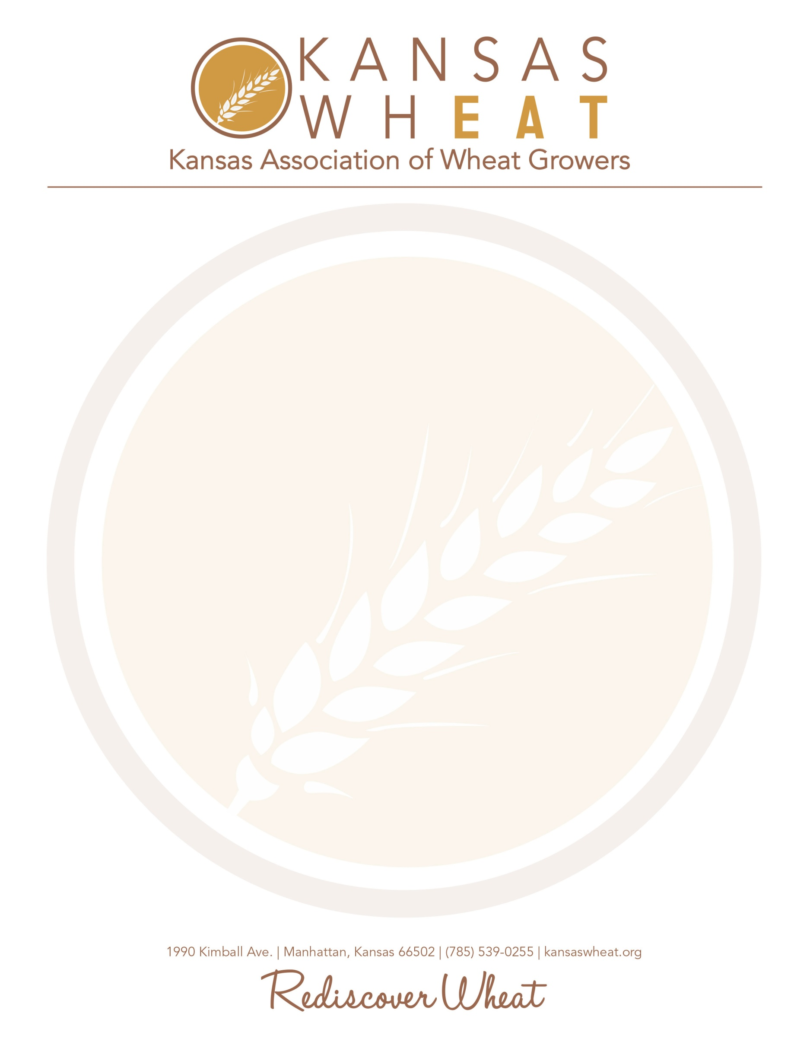

2022 Herb Clutter Memorial Scholarship

The scholarship fund will award one $1,000 scholarship per year, to a college or university-bound incoming freshman from Kansas, pursuing a career in the field of agriculture. To be eligible for the scholarship, applicants must plan to be a full-time student at any two or four year college or university in Kansas.
Guidelines:
- Submit typed application with signature, postmarked by Friday, March 18, 2022.
- Include high school transcript with application.
- If given space for requested information (awards and honors, community service, etc.) is not adequate, please provide typed list or resume in addition to the sheet provided.
- Attach a 400-500 word essay sharing why you have chosen to pursue a career in agriculture.

Personal Information:
Name: ________________________________Date of Birth: _____________________
Address: _____________________________ _________________________________
City: ___________________ County: ______________ Zip: ___________
Name of Parents/Guardian: _______________________________________________
Home Phone: ____________________________
E-Mail Address: ________________________________________________________
Education Information:
High School: ___________________________________________________________
College planning to attend: ________________________________________________
Field of Study: _________________________________________________________
High School GPA: ______________________ Class Rank: _____________________

Honors and Awards Received:
Organization | Dates of Participation | Leadership Role

Community Service:
Activity | Roles and Responsibilities

Student Group Organizations:
Organization | Dates of Participation | Leadership Role

Employment Experience:
Employer | Dates of Employment | Responsibilities

Please attach an essay sharing why you have chosen to pursue a career in agriculture. The essay should be between 400-500 words.
SIGN HERE: ________________________________
Mail your completed application by March 18, 2022 to:
Kansas Wheat
Attn: Shayna DeGroot
1990 Kimball Ave
Manhattan, KS 66502

