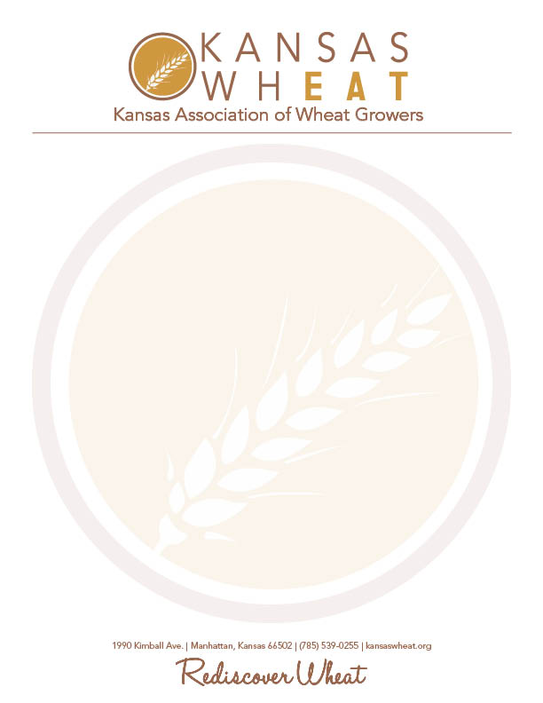

Kansas Association of Wheat Growers
2018 Herb Clutter Memorial Scholarship

The scholarship fund will award one $500 scholarship per year, to a college or university-bound incoming freshman from Kansas, pursuing a career in the field of agriculture. To be eligible for the scholarship, applicants must plan to be a full-time student at any two or four year college or university in Kansas.
Guidelines:
- Submit typed application with signature postmarked by Friday, March 2, 2018.
- Include high school transcript along with application.
- Attach a 400-500 word essay sharing why you have chosen to pursue a career in agriculture.

Personal Information:
Name: ________________________________Date of Birth: _____________________
Address: _____________________________ _________________________________
City: ___________________ County: ______________ Zip: ___________
Name of Parents/Guardian: _______________________________________________
Home Phone: ____________________________
E-Mail Address: ________________________________________________________
Education Information:
High School: ___________________________________________________________
College planning to attend: ________________________________________________
Field of Study: _________________________________________________________
High School GPA: ______________________ Class Rank: _____________________

Honors and Awards Received:
Organization | Dates of Participation | Leadership Role

Community Service:
Activity | Roles and Responsibilities

Student Group Organizations:
Organization | Dates of Participation | Leadership Role

Employment Experience:
Employer | Dates of Employment | Responsibilities

Please attach an essay sharing why you have chosen to pursue a career in agriculture. The essay should be between 400-500 words.
Mail your completed application by March 2, 2018 to:
Kansas Wheat
Attn: Jordan Hildebrand
1990 Kimball Ave
Manhattan, KS 66502

